Paste the code in the VBA editor, and your new RegExpMatch function is ready for use. If you are not very experienced with VBA, this guide may be helpful: How to insert VBA code in Excel.
Note. After inserting the code, remember to save your file as a macro-enabled workbook (.xlsm).

RegExpMatch syntax
The RegExpMatch function checks whether any part of the source string matches a regular expression. The result is a Boolean value: TRUE if at least one match is found, FALSE otherwise.
Our custom function has 3 arguments - the first two are required and the last one is optional:
RegExpMatch(text, pattern, [match_case])
Where:
- Text(required) - one or more strings to search in. Can be supplied as a cell or range reference.
- Pattern(required) - the regular expression to match. When placed directly in a formula, a pattern must be enclosed in double quotes.
- Match_case (optional) - defines the match type. If TRUE or omitted (default), case-sensitive matching is performed; if FALSE - case-insensitive.
The function works in all versions of Excel 365, Excel 2021, Excel 2019, Excel 2016, Excel 2013 and Excel 2010.

3 things you should know about RegExpMatch
Before we get to practical calculations, please take notice of the following points that clarify some technicalities:
- The function can process a single cell or range of cells. In the latter case, the results are returned in the neighboring cells in the form of a dynamic array, or spill range, like shown in this example.
- By default, the function is case-sensitive. To ignore text case, set the match_case argument to FALSE. Because of the VBA Regexp limitations, the case-insensitive pattern (?i) is not supported.
- If a valid pattern is not found, the function returns FALSE; if the pattern is invalid, a #VALUE! error occurs.
Below, you'll find a few regex match examples that were created for demonstration purposes. We cannot guarantee that our patterns will work faultlessly with a wider range of input data in your real worksheets. Before putting in production, be sure to test and adjust our samples patterns according to your needs.

How to use regex to match strings in Excel
When all the strings you want to match have the same pattern, regular expressions are an ideal solution.
Supposing you have a range of cells (A5:A9) containing various details about some items. You wish to know which cells have SKUs. Assuming that each SKU consists of 2 capital letters, a hyphen, and 3 digits, you can match them using the following expression.
Pattern: \b[A-Z]{2}-\d{3}\b
Where [A-Z]{2} means any 2 uppercase letters from A to Z and \d{3} means any 3 digits from 0 to 9. The \b character denotes a word boundary, meaning an SKU is a separate word, and not part of a bigger string such as 23-MAR-2022.
With the pattern established, we can move on to writing a formula. Essentially, using a custom function is no different from a native one. As soon as you start typing a formula, the function's name will appear in the list suggested by Excel's AutoComplete. However, there are a couple of nuances in Dynamic Array Excel (Microsoft 365 and Excel 2021) and traditional Excel (2019 and older versions).

Match string in one cell
To match a string in a single cell, refer to that cell in the first argument. The second argument is supposed to contain a regular expression.
=RegExpMatch(A5, "\b[A-Z]{2}-\d{3}\b")
The pattern can also be kept in a predefined cell, which is locked with an absolute reference ($A$2):
=RegExpMatch(A5, $A$2)
After entering the formula in the first cell, you can drag it down to all other rows.
This method works beautifully in all Excel versions.
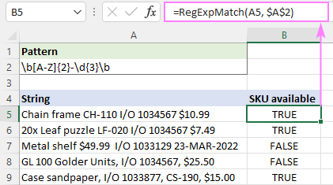

Match strings in multiple cells at once
To match multiple strings with a single formula, include a range reference in the first argument:
=RegExpMatch(A5:A9, "\b[A-Z]{2}-\d{3}\b")
In Excel 365 and Excel 2021 that support dynamic arrays, it works this way - you type the formula in the first cell, hit Enter, and the formula automatically spills into the below cells.
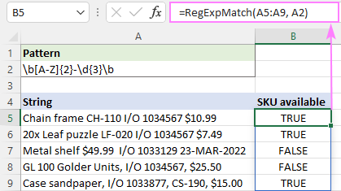
In Excel 2019 and earlier, it only works as a traditional CSE array formula, which is entered in a range of cells and completed by pressing the Ctrl + Shift + Enter keys together.
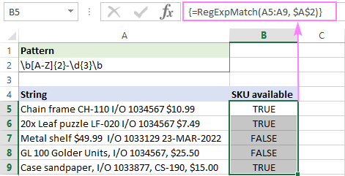

Regex to match number
To match any single digit from 0 to 9, use the \d character in the regex. Depending on your particular task, add a suitable quantifier or create a more complex pattern.

Regex to match any number
To match any number of any length, put the + quantifier right after the /d character, which says to look for numbers containing 1 or more digits.
Pattern: \d+
=RegExpMatch(A5:A9, "\d+")
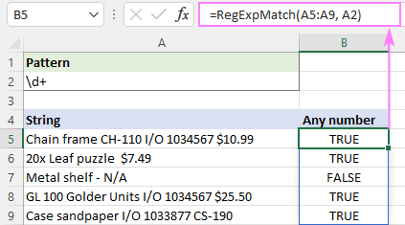

Regex to match number of specific length
If your goal is to match numeric values containing a certain number of digits, then use \d together with an appropriate quantifier.
For example, to match invoice numbers consisting of exactly 7 digits, you'd use \d{7}. However, please keep in mind that it will match 7 digits anywhere in the string including a 10-digit or 100-digit number. If this is not what you are looking for, put the word boundary \b on both sides.
Pattern: \b\d{7}\b
=RegExpMatch(A5:A9, "\b\d{7}\b")
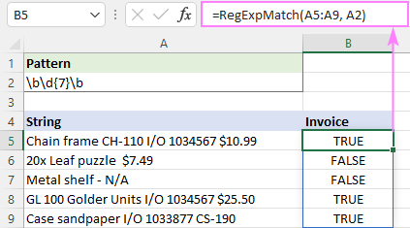

Regex to match phone numbers
Since phone numbers can be written in various formats, matching them requires a more sophisticated regular expression.
In the below dataset, we will be searching for 10-digit numbers that have 3 digits in the first 2 groups and 4 digits in the last group. The groups can be separated with a period, hyphen or space. The first group may or may not be enclosed in parentheses.
Pattern: (\(\d{3}\)|\d{3})[-\.\s]?\d{3}[-\.\s]?\d{4}\b
Breaking down this regular expression, here's what we get:
- The first part (\(\d{3}\)|\d{3}) matches a 3-digit number either inside the parentheses or without parentheses.
- The [-\.\s]? part means 0 or 1 occurrence of any character in square brackets: hyphen, period, or whitespace.
- Next, there is one more group of 3 digits d{3} followed by any hyphen, period or whitespace [\-\.\s]? appearing 0 or 1 time.
- The last group of 4 digits \d{4} is followed by a word boundary \b to make it clear that a phone number cannot be part of a bigger number.
With the original string in A5 and the regular expression in A2, the formula takes this form:
=RegExpMatch(A5, $A$2)
… and works exactly as expected:
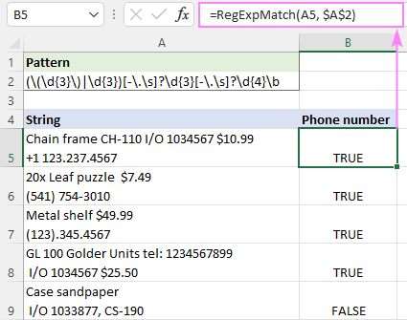
Notes:
- International codes are not checked, so they may or may not be present.
- In regular expressions, \s stands for any whitespace character such as a space, tab, carriage return, or new line. To allow only spaces, use [-\. ] instead of [-\.\s].

Regex to NOT match character
To find strings that do NOT contain a certain character, you can use negated character classes [^ ] that match anything NOT in brackets. For example:
- [^13] will match any single character that is not 1 or 3.
- [^1-3] will match any single character that is not 1, 2 or 3 (i.e. any digit from 1 to 3).
In a list of phone numbers, suppose you want to find those that do not have a country code. Keeping in mind that any international code includes the + sign, you can use the [^\+] character class to find strings that do not contain a plus sign. It is important to realize that the above expression matches any single character that is not +. Because a phone number can be anywhere in a string, not necessarily in the very beginning, the * quantifier is added to check each subsequent character. The start ^ and end $ anchors ensure that the entire string is processed. As the result, we get the below regular expression that says "don't match the + character in any position in the string".
Pattern: ^[^\+]*$
=RegExpMatch(A5, "^[^\+]*$")
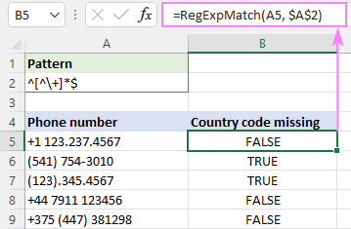

Regex to NOT match string
Though there is no special regular expression syntax for not matching a specific string, you can emulate this behavior by using a negative lookahead.
Supposing you wish to find strings that do not contain the word "lemons". This regular expression will work a treat:
Pattern: ^((?!lemons).)*$
Obviously, some explanation is needed here. The negative lookahead (?!lemons) looks to the right to see if there's no word "lemons" ahead. If "lemons" is not there, then the dot matches any character except a line break. The above expression performs just one check, and the * quantifier repeats it zero or more times, from the start of the string anchored by ^ to the end of the string anchored by $.
To ignore the text case, we set the 3th argument to FALSE to make our function case-insensitive:
=RegExpMatch(A5, $A$2, FALSE)
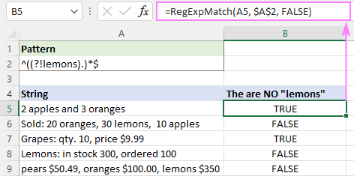
Tips and notes:
- The above regex only works for single-line strings. In case of milti-line strings, the ^ and $ characters match the beginning and end of each line instead of the beginning and end of the input string, therefore the regex only searches in the first line.
- To match strings that do not start with certain text, use a regular expression such as ^(?!lemons).*$
- To match strings that do not end with certain text, include the end string anchor into the search pattern: ^((?!lemons$).)*$

Case insensitive matching
In classic regular expressions, there is a special pattern for case-insensitive matching (?i), which is not supported in VBA RegExp. To overcome this limitation, our custom function accepts the 3rd optional argument named match_case. To do case-insensitive matching, simply set it to FALSE.
Let's say you wish to identify dates such as 1-Mar-22 or 01-MAR-2022. To match the dd-mmm-yyyy and d-mmm-yy formats, we are using the following regular expression.
Pattern: \b\d{1,2}-(Jan|Feb|Mar|Apr|May|Jun|Jul|Aug|Sep|Oct|Nov|Dec)-(\d{4}|\d{2})\b
Our expression searches for a group of 1 or 2 digits, followed by a hyphen, followed by any of the month abbreviations separated by | which enables the OR logic, followed by a group of 4 or 2 digits.
Why not use a simpler pattern such as \d{1,2}-[A-Za-z]{3}-\d{2,4}\b? To prevent false positive matches like 01-ABC-2020.
Enter the pattern in A2, and you'll get the following formula:
=RegExpMatch(A5, $A$2, FALSE)
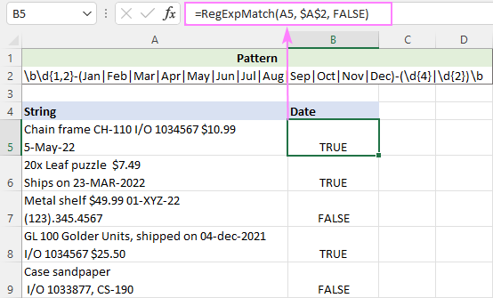

Regex to match valid email addresses
As generally known, an email address consists of 4 parts: username, @ symbol, domain name (mail server) and top-level domain (such as .com, .edu, .org, etc.). To check the email address validity, we'll need to replicate the above structure using regular expressions.
Pattern: \b[\w\.\-]+@[A-Za-z0-9]+[A-Za-z0-9\.\-]*[A-Za-z0-9]+\.[A-Za-z]{2,24}\b
To better understand what's going on here, let's take a closer look at each part:
- Username may include letters, numbers, underscores, dots and hyphens. Keeping in mind that \w matches any letter, digit or underscore, we get the following regex: [\w\.\-]+
- Domain name may include uppercase and lowercase letters, digits, hyphens (but not in the first or last position) and dots (in case of subdomains). Since underscores are not allowed, instead of \w we are using 3 different character sets: [A-Za-z0-9]+[A-Za-z0-9\.\-]*[A-Za-z0-9]+
- Top-level domain consists of a dot followed by uppercase and lowercase letters. It can contain from 2 to 24 letters (the longest TLD currently in existence): \.[A-Za-z]{2,24}
Note. The pattern assumes the domain name contains 2 or more alphanumeric characters.
With the original text in A5 and the pattern in A5, the formula takes this shape:
=RegExpMatch(A5, $A$2)
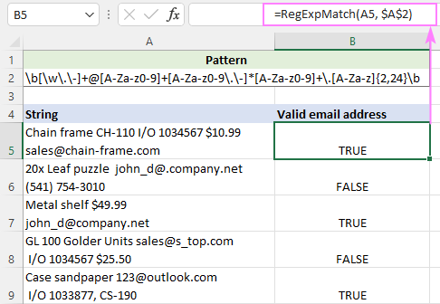
Or you could use a simpler regular expression for email validation with either a lowercase or uppercase character set:
Pattern: \b[\w\.\-]+@[a-z0-9]+[a-z0-9\.\-]*[a-z0-9]+\.[a-z]{2,24}\b
But make your formula case-insensitive:
=RegExpMatch(A5, $A$2, FALSE)

Excel IF formula with match regex
Due to the fact that inbuilt and custom functions go along nicely, there is nothing that would prevent you from using them together in a single formula.
To return or calculate something if a regular expression is matched and something else if it's not matched, embed the custom RegExpMatch function in the logical text of IF:
IF(RegExpMatch(…), [value_if_true], [value_if_false])
For example, if a string in A5 contains a valid email address, you can return "Yes"; otherwise "No".
=IF(RegExpMatch(A5, $A$2,), "Yes", "No")
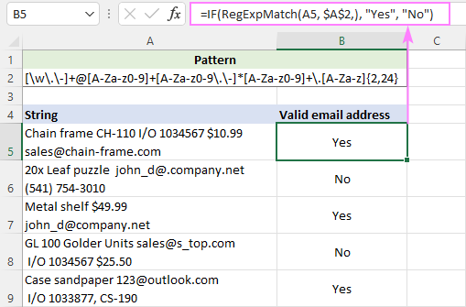

Count if regex is matched
Because native Excel functions don't support regular expressions, it's not possible to put a regex directly in the COUNTIS or COUNTIFS function. Luckily, you can emulate this functionality using our custom function.
Supposing you've used a regex to match phone numbers and output the results in column B. To find out how many cells contain phone numbers, you just need to count the TRUE values in B5:B9. And that can be easily done using the standard COUNTIF formula:
=COUNTIF(B5:B9, TRUE)
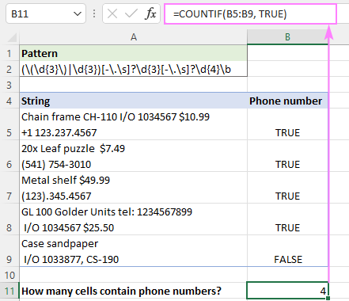
Do not want any extra columns in your worksheet? No problem. Keeping in mind that our custom function can process multiple cells at a time and Excel's SUM can add up values in an array, here's what you do:
- Supply a range reference to RegExpMatch, so it returns an array of TRUE and FALSE values.
- Use a double negation (--) to coerce the logical values to ones and zeros.
- Get the SUM function to add up 1's and 0's in the resulting array.
=SUM(--RegExpMatch(A5:A9, $A$2))
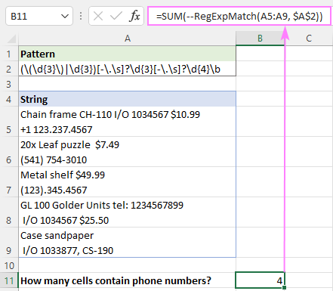

Regex matching with Ultimate Suite
The users of our Ultimate Suite can leverage four powerful Regex functions without adding any VBA code to their workbooks as they are smoothly integrated into Excel during the add-in installation. Our custom functions are processed by the standard .NET RegEx engine and support full-featured classic regular expressions.

How to use custom RegexMatch function
Assuming you have the latest version of Ultimate Suite installed (2021.4 or later), you can create a Regex Match formula in two simple steps:
- On the Ablebits Data tab, in the Text group, click Regex Tools.
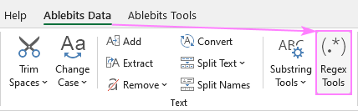
- On the Regex Tools pane, do the following:
  - Select the source strings.
  - Enter your pattern.
  - Choose the Match option.
  - To have the results as formulas, not values, select the Insert as a formula check box.
  - Click the Match button.
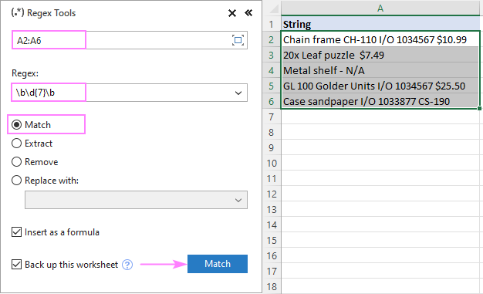
A moment later, the AblebitsRegexMatch function is inserted in a new column to the right of your data.
In the screenshot below, the function checks whether the strings in column A contain 7-digit numbers or not.
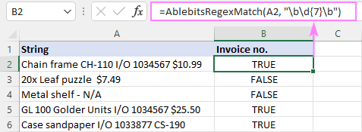
Tips:
- The function can be inserted directly in a cell via the standard Insert Function dialog box, where it is categorized under AblebitsUDFs.
- By default, a regular expression is added to the formula, but you can also keep it in a separate cell. For this, just use a cell reference for the 2nd argument.
- By default, the function is case-sensitive. For case-insensitive matching, use the (?i) pattern.
For more information, please see AblebitsRegexMatch function.

RegExpExtract syntax
The RegExpExtract function searches an input string for values that match a regular expression and extracts one or all matches.
The function has the following syntax:
RegExpExtract(text, pattern, [instance_num], [match_case])
Where:
- Text (required) - the text string to search in.
- Pattern (required) - the regular expression to match. When supplied directly in a formula, the pattern should be enclosed in double quotation marks.
- Instance_num (optional) - a serial number that indicates which instance to extract. If omitted, returns all found matches (default).
- Match_case (optional) - defines whether to match or ignore text case. If TRUE or omitted (default), case-sensitive matching is performed; if FALSE - case-insensitive.
The function works in all versions of Excel 365, Excel 2021, Excel 2019, Excel 2016, Excel 2013 and Excel 2010.

4 things you should know about RegExpExtract
To effectively use the function in your Excel, there are a few important things to take notice of:
- By default, the function returns all found matches into neighboring cells like shown in this example. To get a specific occurrence, supply a corresponding number to the instance_num argument.
- By default, the function is case-sensitive. For case-insensitive matching, set the match_case argument to FALSE. Because of the VBA limitations, the case-insensitive construct (?i) won't work.
- If a valid pattern is not found, the function returns nothing (empty string).
- If the pattern is invalid, a #VALUE! error occurs.
Before you start using this custom function in your worksheets, you need to understand what it is capable of, right? The below examples cover a few common use cases and explain why the behavior may differ in Dynamic Array Excel (Microsoft 365 and Excel 2021) and traditional Excel (2019 and older versions).
Note. Out regex examples are written for fairy simple data sets. We cannot guarantee they will work flawlessly in your real worksheets. Those who have experience with regex would agree that writing regular expressions is a never-ending road to perfection - almost always there's a way to make it more elegant or capable of handling a wider range of input data.

Regex to extract number from string
Following the basic maxim of teaching "from simple to complex", we'll start with a very plain case: extracting number from string.
The first thing for you to decide is which number to retrieve: first, last, specific occurrence or all numbers.

Extract first number
This is as simple as regex can get. Given that \d means any digit from 0 to 9, and + means one or more times, our regular expression takes this form:
Pattern: \d+
Set instance_num to 1 and you'll get the desired result:
=RegExpExtract(A5, "\d+", 1)
Where A5 is the original string.
For convenience, you can input the pattern in a predefined cell ($A$2 ) and lock its address with the $ sign:
=RegExpExtract(A5, $A$2, 1) 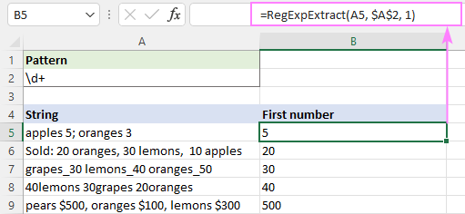

Get last number
To extract the last number in a string, here's the pattern to use:
Pattern: (\d+)(?!.*\d)
Translated into a human language, it says: find a number that is not followed (anywhere, not just immediately) by any other number. To express this, we are using a negative lookahead (?!.*\d), which means that to the right of the pattern there should be no other digit (\d) regardless of how many other characters are before it.
=RegExpExtract(A5, "(\d+)(?!.*\d)") 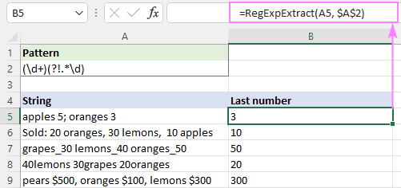
Tips:
- To get a specific occurrence, use \d+ for pattern and an appropriate serial number for instance_num.
- The formula to extract all numbers is discussed in the next example.

Regex to extract all matches
Pushing our example a little further, suppose you want to get all numbers from a string, not just one.
As you may remember, the number of extracted matches is controlled by the optional instance_num argument. The default is all matches, so you simply omit this parameter:
=RegExpExtract(A2, "\d+")
The formula works beautifully for a single cell, but the behavior differs in Dynamic Array Excel and non-dynamic versions.

Excel 365 and Excel 2021
Due to support for dynamic arrays, a regular formula automatically spills into as many cells as needed to display all calculated results. In terms of Excel, this is called a spilled range: 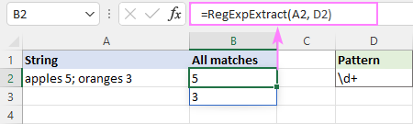

Excel 2019 and lower
In pre-dynamic Excel, the above formula would return just one match. To get multiple matches, you need to make it an array formula. For this, select a range of cells, type the formula, and press Ctrl + Shift + Enter to complete it.
A downside of this approach is a bunch of #N/A errors appearing in "extra cells". Regrettably, nothing can be done about it (neither IFERROR nor IFNA can fix it, alas). 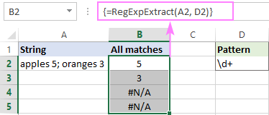

Extract all matches in one cell
When processing a column of data, the above approach obviously won't work. In this case, an ideal solution would be returning all matches in a single cell. To have it done, serve the results of RegExpExtract to the TEXTJOIN function and separate them with any delimiter you like, say a comma and a space:
=TEXTJOIN(", ", TRUE, RegExpExtract(A5, "\d+")) 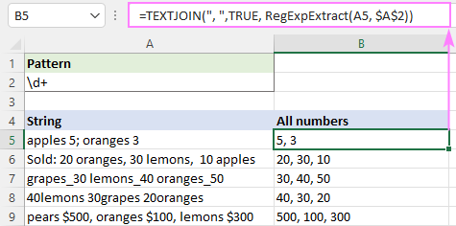
Note. Because the TEXTJOIN function is only available in Excel for Microsoft 365, Excel 2021 and Excel 2019, the formula won't work in older versions.

Regex to extract text from string
Extracting text from an alphanumeric string is quite a challenging task in Excel. With regex, it becomes as easy as pie. Just use a negated class to match everything that is not a digit.
Pattern: [^\d]+
To get substrings in individual cells (spill range), the formula is:
=RegExpExtract(A5, "[^\d]+") 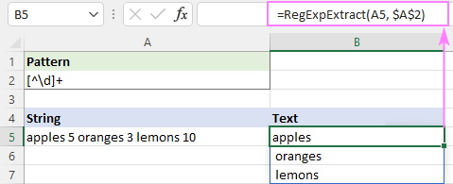
To output all matches into one cell, nest the RegExpExtract function in TEXTJOIN like this:
=TEXTJOIN("", TRUE, RegExpExtract(A5, "[^\d]+")) 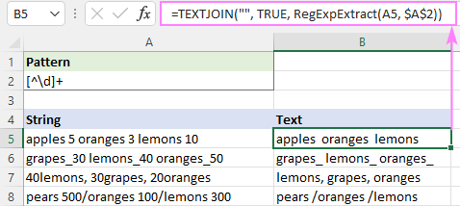

Regex to extract email address from string
To pull out an email address from a string containing a lot of different information, write a regular expression that replicates the email address structure.
Pattern: [\w\.\-]+@[A-Za-z0-9\.\-]+\.[A-Za-z]{2,24}
Breaking down this regex, here's what we get:
- [\w\.\-]+ is a username that may include 1 or more alphanumeric characters, underscores, dots and hyphens.
- @ symbol
- [A-Za-z0-9\.\-]+ is a domain name consisting of: uppercase and lowercase letters, digits, hyphens and dots (in case of subdomains). Underscores are not allowed here, therefore 3 different character sets (such as A-Z a-z and 0-9) are used instead of \w that matches any letter, digit or underscore.
- \.[A-Za-z]{2,24} is a top-level domain. Consists of a dot followed by uppercase and lowercase letters. Most of top-level domains are 3-letters long (e.g .com .org, .edu, etc.), but in theory it can contain from 2 to 24 letters (the longest registered TLD).
Assuming the string is in A5 and the pattern in A2, the formula to extract an email address is:
=RegExpExtract(A5, $A$2) 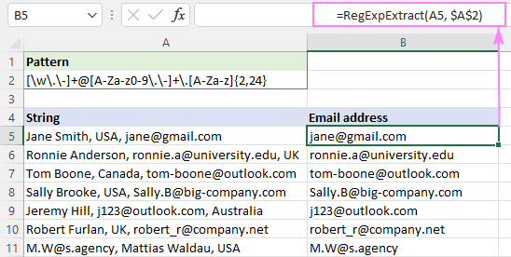

Regex to extract domain from email
When it comes to extracting email domain, the first thought that comes to mind is using a capturing group to find text that immediately follows the @ character.
Pattern: @([A-Za-z0-9\.\-]+\.[A-Za-z]{2,24})
Serve it to our RegExp function:
=RegExpExtract(A5, "@([A-Za-z0-9\.\-]+\.[A-Za-z]{2,24})")
And you'll get this result: 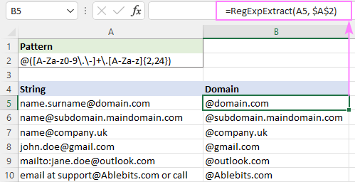
With classic regular expressions, anything outside a capturing group is not included in the extraction. No one knows why VBA RegEx works differently and captures "@" as well. To get rid of it, you can remove the first character from the result by replacing it with an empty string.
=REPLACE(RegExpExtract(A5, "@([a-z\d][a-z\d\-\.]*\.[a-z]{2,})", 1, FALSE), 1, 1, "") 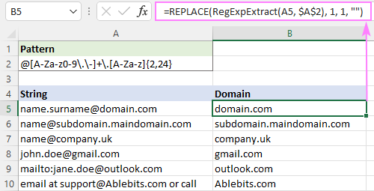

Regular expression to extract phone numbers
Phone numbers can be written in many different ways, which is why it's next to impossible to come up with a solution working under all circumstances. Nevertheless, you can write down all the formats used in your dataset and try to match them.
For this example, we are going to create a regex that will extract phone numbers in any of these formats:
(123) 345-6789  (123) 345 6789  (123)3456789  123-345-6789 | 123.345.6789  123 345 6789  1233456789
Pattern: \(?\d{3}[-\. \)]*\d{3}[-\. ]?\d{4}\b
- The first part \(?\d{3} matches zero or one opening parenthesis followed by three digits d{3}.
- The [-\. \)]* part means any character in square brackets appearing 0 or more times: hyphen, period, space or closing parenthesis.
- Next, we have three digits again d{3} followed by any hyphen, period or space [-\. ]? appearing 0 or 1 time.
- After that, there is a group of four digits \d{4}.
- Finally, there is a word boundary \b defining that a phone number we are looking for cannot be part of a bigger number.
The complete formula takes this shape:
=RegExpExtract(A5, "\(?\d{3}[-\. \)]*\d{3}[-\. ]?\d{4}\b") 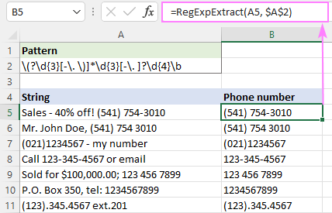
Please be aware that the above regex may return a few false-positive results such as 123) 456 7899 or (123 456 7899. The below version fixes these issues. However, this syntax only works in VBA RegExp functions, not in classic regular expressions.
Pattern: (\(\d{3}\)|\d{3})[-\. ]?\d{3}[-\. ]?\d{4}\b

Regex to extract date from string
A regular expression for extracting a date depends on the format in which the date appears within a string. For example:
To extract dates like 1/1/21 or 01/01/2021, the regex is: \d{1,2}\/\d{1,2}\/(\d{4}|\d{2})
It searches for a group of 1 or 2 digits d{1,2} followed by a slash, followed by another group of 1 or 2 digits, followed by a slash, followed by a group of 4 or 2 digits (\d{4}|\d{2}). Please notice that we look for 4-digit years first, and only then for 2-digit years. If we write it the other way around, only the first 2 digits will be picked out from all the years. This is because after the first condition is in the alternation OR construct is matched, the remaining conditions are not checked.
To retrieve dates like 1-Jan-21 or 01-Jan-2021, the pattern is: \d{1,2}-[A-Za-z]{3}-\d{2,4}
It searches for a group of 1 or 2 digits, followed by a hyphen, followed by a group of 3 uppercase or lowercase letters, followed by a hyphen, followed by a group of 4 or 2 digits.
After combining the two patterns together, we get the following regex:
Pattern: \b\d{1,2}[\/-](\d{1,2}|[A-Za-z]{3})[\/-](\d{4}|\d{2})\b
Where:
- The first part is 1 or 2 digits: \d{1,2}
- The second part is either 1 or 2 digits or 3 letters: (\d{1,2}|[A-Za-z]{3})
- The third part is a group of 4 or 2 digits: (\d{4}|\d{2})
- Delimiter is either a forward slash or hyphen: [\/-]
- A word boundary \b is placed on both sides to make it clear that a date is a separate word, and not part of a bigger string.
As you can see in the image below, it successfully pulls out dates and leaves out substrings such as 11/22/333. However, it still returns false positive results. In our case, the substring 11-ABC-2222 in A9 technically matches the date format dd-mmm-yyyy and therefore is extracted. 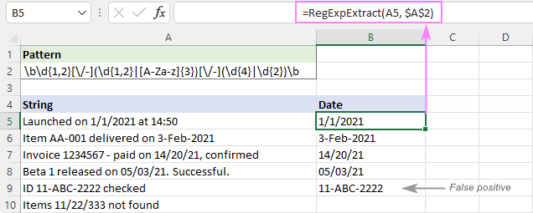
To eliminate false positives, you can replace the [A-Za-z]{3} part with a full list of 3-letter month abbreviations:
Pattern: \b\d{1,2}[\/-](\d{1,2}|(Jan|Feb|Mar|Apr|May|Jun|Jul|Aug|Sep|Oct|Nov|Dec))[\/-](\d{4}|\d{2})\b
To ignore the letter case, we set the last argument of our custom function to FALSE:
=RegExpExtract(A5, $A$2, 1, FALSE)
And this time, we get a perfect result: 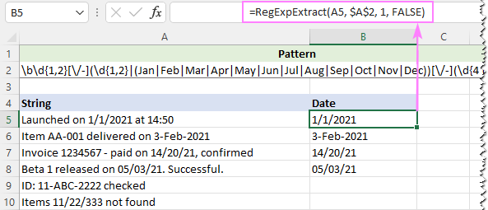

Regex to extract time from string
To get time in the hh:mm or hh:mm:ss format, the following expression will work a treat.
Pattern: \b(0?[0-9]|1[0-2]):[0-5]\d(:[0-5]\d)?\s?(AM|PM)\b|\b([0-9]|[0-1]\d|2[0-3]):[0-5]\d(:[0-5]\d)?(?!:)
Breaking down this regex, you can see 2 parts separated by | that enables the OR logic. In other words, we search for a substring that matches one of the below expressions.
Expression 1: \b(0?[0-9]|1[0-2]):[0-5]\d(:[0-5]\d)?\s?(AM|PM)\b
Retrieves times with AM/PM.
Hour can be any number from 0 to 12. To get it, we use the OR construct ([0-9]|1[0-2]), where:
- [0-9] matches any number from 0 to 9
- 1[0-2] matches any number from 10 to 12
Minute [0-5]\d is any number from 00 to 59.
Second (:[0-5]\d)? is also any number from 00 to 59. The ? quantifier means zero or one occurrence since seconds may or may not be included in the time value.
Expression 2: \b([0-9]|[0-1]\d|2[0-3]):[0-5]\d(:[0-5]\d)?(?!:)
Extracts times without AM/PM.
The hour part can be any number from 0 to 32. To get it, a different OR construct ([0-9]|[0-1]\d|2[0-3]) is used, where:
- [0-9] matches any number from 0 to 9
- [0-1]\d matches any number from 00 to 19
- 2[0-3] matches any number from 20 to 23
The minute and second parts are the same as in expression 1 above.
The negative lookahead (?!:) is added to skip strings such as 20:30:80.
As PM/AM can be either uppercase or lowercase, we make the function case-insensitive:
=RegExpExtract(A5, $A$2, 1, FALSE) 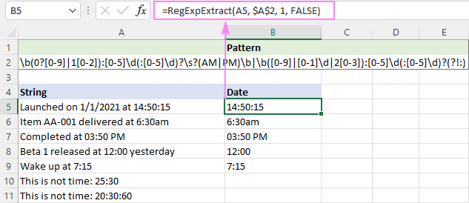
Hopefully, the above examples gave you some ideas on how to use regular expressions in your Excel worksheets. Unfortunately, not all features of classic regular expressions are supported in VBA. If your task cannot be accomplished with VBA RegExp, I encourage you to read the next part that discusses a lot more powerful .NET Regex functions.

Custom .NET based Regex function to extract text in Excel
Unlike VBA RegExp functions that can be written by any Excel user, .NET RegEx is the developer's realm. The Microsoft .NET Framework supports full-featured regular expression syntax compatible with Perl 5. This article won't teach you how to write such functions (I am not a programmer and don't have a slightest idea on how to do that :)
Four powerful functions processed by the standard .NET RegEx engine are already written by our developers and included in Ultimate Suite. Below, we'll demonstrate some practical uses of the function specially designed for extracting text in Excel.
Tip. For information about the .NET Regex syntax, please refer to .NET Regular Expression Language.

How to extract stings in Excel using regular expressions
Assuming you have the latest version of Ultimate Suite installed, extracting text using regular expressions boils down to these two steps:
- On the Ablebits Data tab, in the Text group, click Regex Tools.
- On the Regex Tools pane, select the source data, enter your Regex pattern, and choose the Extract option. To get the result as a custom function, not a value, select the Insert as a formula check box. When done, click the Extract button. 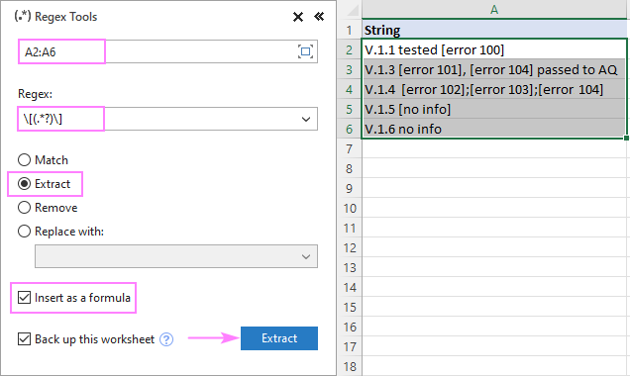

RegExpReplace syntax
The RegExpReplace function searches an input string for values that match a regular expression and replaces the found matches with the text you specify.
The function accepts 5 arguments, but only the first three are required.
RegExpReplace(text, pattern, text_replace, [instance_num], [match_case])
Where:
- Text (required) - the text string to search in.
- Pattern (required) - the regular expression to match.
- Text_replace (required) - the text to replace the matching substrings with.
- Instance_num (optional) - a serial number indicating which instance to replace. If omitted, the function will replace all found matches (default).
- Match_case (optional) - controls whether to match or ignore text case. If TRUE or omitted (default), the search is case-sensitive; if FALSE - case-insensitive.
The function works in all versions of Excel 365, Excel 2021, Excel 2019, Excel 2016, Excel 2013 and Excel 2010.

Usage notes
To ensure that your results will meet your expectations, let's take a closer look at the inner mechanics:
- By default, the function works in the Replace all mode. To substitute a specific occurrence, put a corresponding number in the instance_num argument.
- By default, the function is case-sensitive. For case-insensitive search, set the match_case argument to FALSE. Because of the VBA RegExp limitations, the classic case-insensitive pattern (?i) is not supported.
- When you supply a regex directly in a formula, remember to enclose it in double quotation marks.
- If a valid pattern is not found, the function will return the original string with no changes.
- If the regex is invalid, a #VALUE! error will occur.

Excel Regex replace examples
Assuming you've already inserted the RegExpReplace function in your workbook, let's get to more fascinating things - using regular expressions for advanced find and replace in Excel.

Regex to replace string matching a pattern
In the sample dataset below, supposing you want to hide some personal data such as social security numbers. Given that SSN is a nine-digit number in the format "000-00-0000", we are using the following regular expression to find it.
Pattern: \d{3}-\d{2}-\d{4}
For replacement, this string is used:
Replacement text: XXX-XX-XXXX
With the original string in A5, the complete formula takes this form:
=RegExpReplace(A5, "\d{3}-\d{2}-\d{4}", "XXX-XX-XXXX")
For convenience, you can enter the pattern and replacement text in separate cells and refer to those cells in your formula. If you plan to use the formula for multiple cells, remember to lock the cell addresses with the $ sign:
=RegExpReplace(A5, $A$2, $B$2)
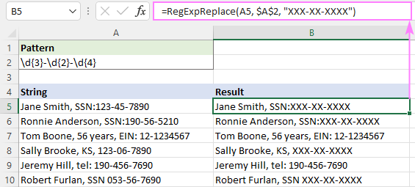

Regex to replace number in a string
To find any single digit from 0 to 9, use \d in your regular expression. To find specific digits, use an appropriate quantifier or construct a more sophisticated regex like shown in the below examples.

Replace all numbers
To replace absolutely all numbers in a string with some character or text, use the + quantifier, which says to search for numbers containing 1 or more digits.
Pattern: \d+
For example, to replace all numbers in cell A5 with an asterisk, use this formula:
=RegExpReplace(A5, "\d+", "*")
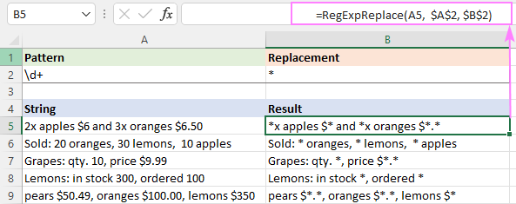

Replace amounts of money
In the same dataset, suppose you wish to replace only the amounts of money and not all the numbers. To have it done, you search for the dollar sign followed by one or more digits \$\d+ - this part matches the dollar unit. After the main unit, there may or may not be a fractional unit. To match it, you look for zero or one period after which come from 0 to 2 digits \.?\d{0,2}. The word boundary \b in the end ensures that the matching value is not part of a bigger number.
Pattern: \$\d+\.?\d{0,2}\b
Serve this regular expression to our custom function and you'll get the follwoing result:
=RegExpReplace(A5, "\$\d+\.?\d{0,2}\b", "*")
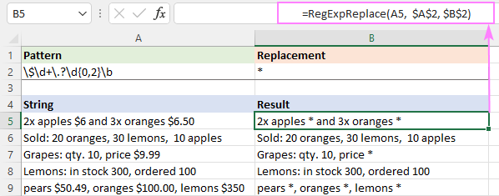

Regex to find and replace all matches
In classic regular expressions, there is the global search flag /g that forces a regex to find all possible matches in a string. In VBA, this flag is not supported. Instead, the VBA RegExp object provides the Global property that defines whether to search for all occurrences or only the first one. In the code of our function, the Global property is set to True, meaning the pattern should be tested against all possible matches in a string.
So, what do you do to replace all occurrences matching a pattern? Nothing special. This behavior is implemented by default.
Let's say you manage an Excel file with personal data. Some information is confidential, so before sharing this file with your colleagues, you want to replace sensitive info such as social security numbers (SSN) and individual taxpayer identification numbers (ITIN) with "CONF".
Given that both SSN and ITIN have the same format, you can find them using the below regular expression.
Pattern: \d{3}-\d{2}-\d{4}
Since the 4th instance_num argument of our function defaults to TRUE, you can safely omit it:
=RegExpReplace(A5, "\d{3}-\d{2}-\d{4}", "CONF")
As the result, all substrings matching the regex are replaced with the specified text:
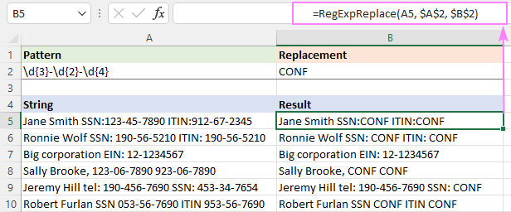

Regex to replace a specific instance
To replace just one occurrence matching a given pattern, define the corresponding number in the instance_num argument.
In the above example, supposing you wish to replace only social security numbers. In all cells, SSN is listed first, so we are replacing the 1st instance:
=RegExpReplace(A5, $A$2, $B$2, 1)
Where $A$2 is the pattern and $B$2 is the replacement text.
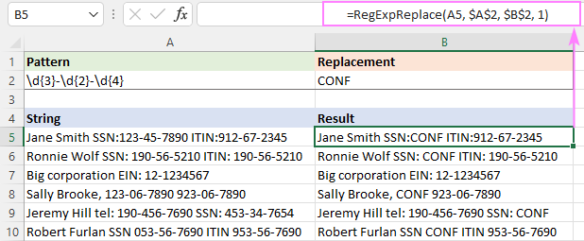

Search and replace in Excel with Regex Tools
Have you heard about the recent addition to our Ultimate Suite? I mean four powerful Regex Tools introduced in the latest version. Compared to their VBA counterparts, the Ablebits Regex functions have two main advantages:
- You can use regular expressions in normal .xlsx workbooks without having to insert any code or enable macros in your Excel.
- Processed by the standard .NET RegEx engine, these functions support full-featured classic regular expressions and overcome many limitations of VBA RegExp.
For more information, please see AblebitsRegexReplace function.
Below, you will find an example of Regex Replace that cannot be done with VBA.

How to replace strings using regular expressions
Let's say you aim to replace text in square brackets with some character or string. The task can be accomplished with either a capturing group or positive look-arounds. The former is an easier way, so we'll stick to it.
Generally, to find a character that is "special" in regular expressions, you need to put a backslash right before it. In regexes, \ acts as an escape character that cancels the special meaning of the following character and turns it into a literal character. So, to find a bracket, you prefix it with a backslash: \[ to match an opening bracket and \] to match a closing bracket. Between the brackets, place a (capturing group). Depending on which quantifier you use in the group, different replacements will be made.
Greedy pattern: \[(.*)\]
This pattern performs a greedy search - consumes as much as possible. The .* expression matches as many characters as possible, and then tries to match ]. So, this pattern captures everything from the first opening bracket to the last closing bracket.
Lazy pattern: \[(.*?)\]
This pattern performs a lazy search - consumes as little as possible. The question mark ? forces .* to match as few characters as possible until it finds the next match in the pattern, which is ]. So, this pattern captures everything from the first opening bracket to the first closing bracket.
Negated class: \[([^\]]*)\]
One more way to match a substring in square brackets is to use a negation operator (^) inside the capturing group. From the first opening bracket, this pattern captures any characters other than a closing bracket, until it finds the first closing bracket. The result will be the same as with the lazy search.
Once you've decided on the regex, go "feed" it to the Ablebits Regex Replace function. Here's how:
- On the Ablebits Data tab, in the Text group, click Regex Tools.
- On the Regex Tools pane, configure these settings:
  - Select the source strings.
  - Enter your pattern.
  - Choose the Replace with option and type the replacement text in the box.
  - To have the results as formulas, not values, select the Insert as a formula check box.
  - Click the Replace button.
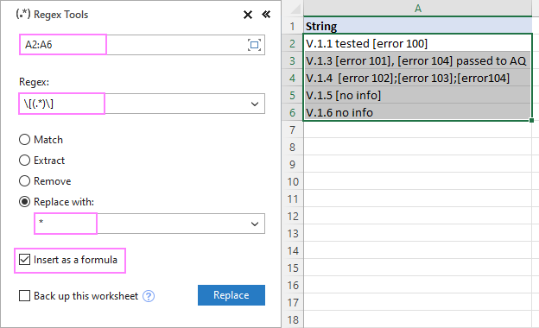
At a moment's notice, the AblebitsRegexReplace function is inserted in a new column to the right of your original data.
=AblebitsRegexReplace(A2, "\[(.*)\]", "*")
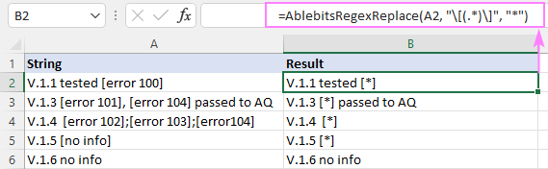
The pattern and replacement text you specify go to the 2nd and 3rd arguments, respectively. Alternatively, you can keep them in separate cells, and supply the corresponding cell references. In our case, we enter the patterns in cells B2 and C2, type the replacement value in A2, then compare the results and choose the desired outcome:
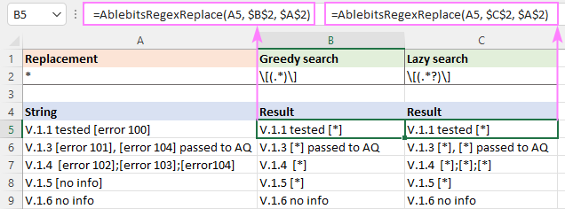
Tips and notes:
- The AblebitsRegexReplace function finds and replaces all matches.
- The function can be inserted directly in a cell via the standard Insert Function dialog box, where it is categorized under AblebitsUDFs.
That's how to find and replace text strings in Excel using regular expressions. I thank you for reading and look forward to seeing you on our blog next week!

The results will appear in a new column to the right of your original data: 